Week9 Project
Part Two: Data-Driven Narrative
10. Describe the Purpose and Audiences for Your Data-Driven Narrative
The purpose of this data-driven narrative is to analyze trends within the data science job market and communicate meaningful insights derived from salary and job posting data. The analysis combines information from two datasets: the Data Science Salaries 2024 dataset and the Data Science Canada March 2024 Jobs dataset. By examining compensation levels, experience requirements, hiring demand, company characteristics, and remote work opportunities, the project identifies patterns that can support informed decision-making.
The narrative is intended to help stakeholders understand the current state of the data science labor market and use that information to make strategic decisions.
10A. Descriptions of the Two Groups of Stakeholders
Stakeholder Group 1: HR Managers and Recruiters
HR managers and recruiters are responsible for attracting, hiring, and retaining qualified employees. These stakeholders need information regarding salary expectations, hiring demand, and workforce trends to make effective recruitment and compensation decisions. The findings from this analysis help HR professionals benchmark salaries, understand which roles are most competitive, and identify areas where organizations may need to adjust hiring strategies.
Stakeholder Group 2: Data Science Job Seekers
Data science professionals and aspiring job seekers represent the second stakeholder group. These individuals are interested in understanding salary expectations, career growth opportunities, and labor market demand. The findings from this analysis help job seekers identify high-paying career paths, understand how experience impacts compensation, and evaluate employment opportunities within the industry.
11. Develop a Compelling Data-Driven Narrative Using Storytelling Principles
The demand for data science professionals continues to grow as organizations increasingly rely on data-driven decision-making. Businesses across many industries are investing in analytics, artificial intelligence, and machine learning capabilities to improve operational efficiency and gain competitive advantages. As a result, skilled data professionals have become highly valuable within the modern workforce.
The salary analysis revealed substantial variation in compensation among data science positions. Roles such as Data Scientist, Machine Learning Engineer, and Data Engineer consistently appeared among the highest-paying occupations. These positions typically require advanced technical expertise and significant analytical capabilities, which contribute to their higher compensation levels.
Experience level emerged as one of the strongest factors influencing salary. Entry-level professionals generally earned lower salaries than mid-level, senior-level, and executive-level professionals. The visualizations demonstrated a clear upward trend in compensation as experience increased, suggesting that career advancement provides significant financial benefits within the data science field. The analysis also identified the continued importance of remote work opportunities. A substantial portion of positions supported remote or hybrid work arrangements, indicating that organizations continue to embrace flexible work environments. This trend expands employment opportunities by allowing organizations to recruit talent from broader geographic regions.
When salary information was combined with job posting data, a relationship between hiring demand and compensation became evident. Positions with strong hiring demand frequently offered competitive salaries, reflecting the challenges organizations face when recruiting qualified candidates. This relationship demonstrates that labor market demand and compensation often move together.
The analysis tells a clear story: organizations continue to invest heavily in data science talent, demand remains strong for specialized technical roles, and professionals who develop advanced skills and experience are positioned to benefit from significant career opportunities and salary growth.
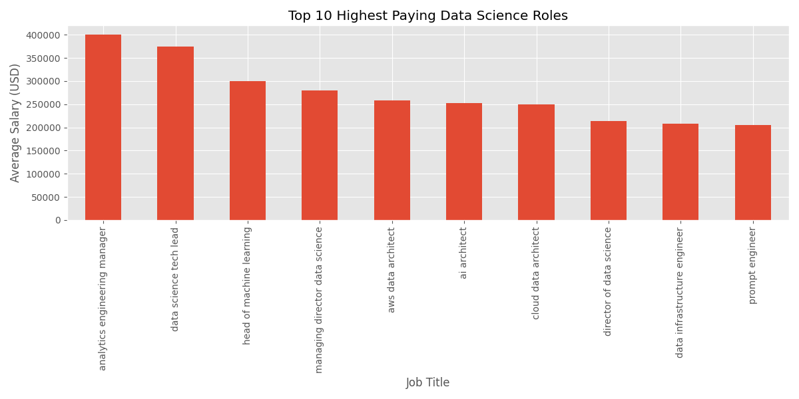
12. Evaluate the Effectiveness of Your Chosen Visualizations in Communicating Your Data Insights
Several visualizations were created to communicate the findings effectively.
The high-level visualization showing the highest-paying data science roles was effective because it provided an immediate overview of compensation differences across occupations. Stakeholders could quickly identify which positions offered the greatest earning potential.
The detailed visualization showing average salary by experience level effectively communicated the relationship between professional experience and compensation. This chart clearly demonstrated how salaries increase as individuals gain experience and advance within their careers.
The salary distribution histogram helped illustrate the overall spread of salaries across the industry. This visualization made it easier to understand common salary ranges and identify unusually high compensation levels.
The remote work distribution chart effectively communicated workplace trends by showing the proportion of remote, hybrid, and on-site positions. The visual format made the information easy to interpret for both technical and non-technical audiences.
The job demand versus salary visualization was particularly effective because it integrated multiple variables into a single chart. By combining hiring demand and compensation information, the visualization revealed relationships that would be difficult to identify from summary statistics alone.
Overall, the visualizations successfully transformed complex datasets into understandable insights and supported effective communication of the project findings.
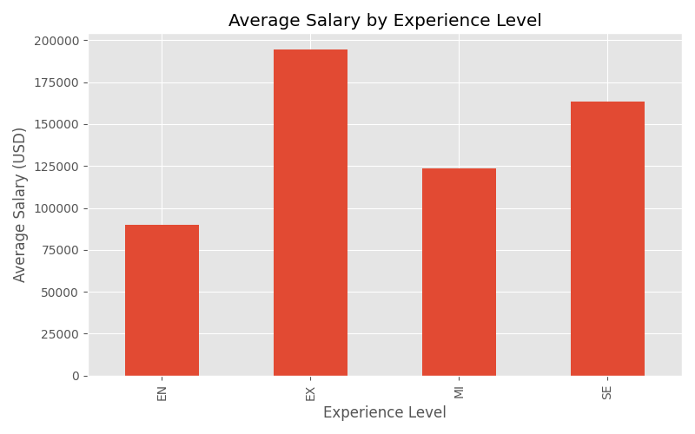
13. Customize Your Integrated Visualizations to Help Each Audience Better Understand the Insights
The visualizations can be customized to better support the needs of each stakeholder group.
For HR managers and recruiters, the job demand versus salary visualization should emphasize hiring demand, salary benchmarking, and workforce planning considerations. Additional labels can be added to highlight positions experiencing the highest demand and the largest salary differences. These enhancements would help HR professionals identify competitive labor market conditions and support recruitment planning.
For data science job seekers, the salary by experience level visualization should emphasize career progression and earning potential. Additional annotations can highlight salary increases associated with moving from entry-level positions to senior-level positions. Similarly, the highest-paying roles chart can highlight occupations that offer the greatest long-term earning opportunities.
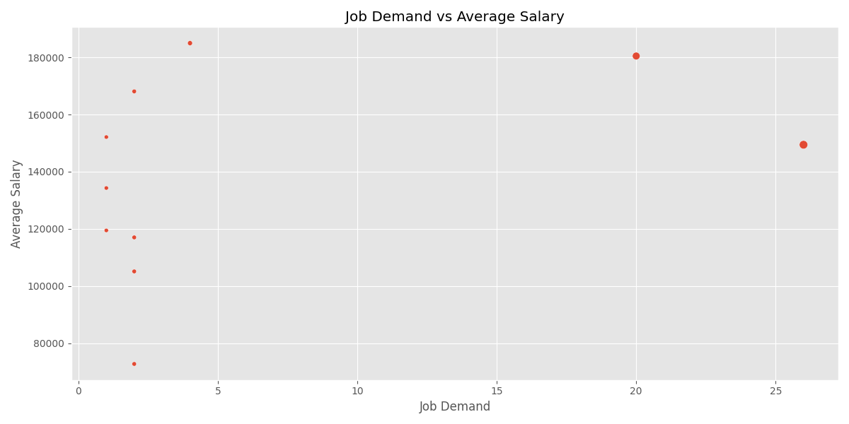
13A. Justification of Customization Choices
The customization choices improve visualization clarity by directing stakeholder attention toward the information most relevant to their specific goals.
For HR managers and recruiters, emphasizing hiring demand and compensation benchmarks supports workforce planning and recruitment decision-making. Highlighting these factors allows organizations to better understand market conditions and allocate resources effectively.
For data science job seekers, emphasizing salary progression and high-paying career paths helps individuals make informed career decisions. Highlighting earning potential and advancement opportunities makes the visualizations more meaningful and actionable for this audience.
By tailoring the visualizations to the needs of each stakeholder group, the analysis becomes easier to understand, more relevant to decision-making, and more effective in communicating key insights.

